|  |
| --- |
| Islamic Education for Children  By  AIMAN ALIF BIN ZANUDDIN  AM1909006034  A Project Proposal  Submitted to  Ms SHUHADAH OTHMAN  Faculty of Computing & Multimedia Kolej Universiti PolyTech MARA |

Contents

1.0 Introduction 3

2.0 PROBLEM STATEMENT 4

3.0 PROJECT OBJECTIVES 4

4.0 PROJECT Scope 5

5.0 TARGET USER 5

6.0 Project Requirement 6

7.0 Project Planning / Methodology 7

8.0 CONCLUSION 8

9.0 GANTt CHART 8

10.0 References 9

# 1.0 Introduction

Islamic Education for Children is an educational application specifically for children aged 2-8 years. Incorporate basic Islamic concepts in child education. These Islamic fun-filled educational are one sure way to make learning about Islam fun for the kids. Many educational learning activities such as Islamic games, quizzes, puzzles, Arabic alphabet games, Islamic stories, and much more. In the context of children, education should be seen as a process that continues to grow simultaneously with the development of a child's individual who is different whatever is in the environment and with the 'knowledge' or skills acquired will apply it in various contexts whether in daily life in that compilation in addition to his life in the future. In other words, everything a child sees and hears from his environment is an education for him because what is real for children at an early age, they cannot distinguish the good and the bad.

The West and Islam have similar perspectives in this regard, children need to be shaped and educated from the very beginning. What makes the difference is that Islam emphasizes the formation of a child's personality not only his physical behavior but the strengthening of morals must be applied in line with the application of faith in their souls.

The current study on this project is how we can give children at an early age to learn Islamic religious knowledge easier. In addition, the content in this application should be appropriate to the age of the child to avoid negative elements that can affect their thinking immature. The resources used to be included in this mobile application must be from trusted and correct sources so that children do not receive religious knowledge information. the deviant.The sources used to be included in this mobile application must be from trusted sources such as websites that guarantee the authenticity of the information given and religious education books written by Muslim authors. This is to prevent children from applying the wrong knowledge of religious education. which causes their beliefs to falter as they grow into adulthood.

This project will involve me with parents that have kids. This mobile application project is designed for children but the views and opinions of parents are very important to ensure the success of this project.

# 2.0 PROBLEM STATEMENT

1. **Overpriced learning tools**

Most parents who are about to give birth to their child will spend money on the preparation of their child including learning tools. The price to buy learning tools in the market is expensive due to the quality tools as well. Parents can reduce their spending costs by using mobile applications that contain fun Islamic learning methods for children.

1. **Entertainment or learning content that is not appropriate for young children**

Parents these days will usually give gadgets to children to prevent children from disturbing parents who are working from home or for other reasons, but the content that is on the internet now is very dangerous because there are adult elements that can affect the thinking of these children. Therefore, parents need to monitor children's behavior and ensure that the applications used are appropriate for their age.

1. **Lack of exposure to the story of the Prophet and his companions**

The mobile application has various stories of the prophets and companions that can be used as a lesson and example to our children. parents can tell children how the prophets and companions spread the teachings of Islam throughout the world at that time.

# 3.0 PROJECT OBJECTIVES

1. To provide mobile applications that can be used without having to spend money. Parents can download this app for their child education for free without having to pay for a monthly or annual pass to get special features because these apps are all available.
2. To make this mobile app suitable for all walks of life with no age limit. Interesting content as well as having pure values, positive teaching and fun.
3. To spread the story of the struggle of the previous prophets who sacrificed to uphold the religion of God. Relaxing and interesting storytelling to attract children to get to know the prophets better.

# 4.0 PROJECT Scope

**4.1 System Scope**

The mobile application will have few features that will give user the best experience. Some of the features that are going to have in the mobile app are Dua with Arabic Audio which compile all authentic dua for Muslim to supplicate on a daily basis and special occasions. This system also can set timer to prevent children from facing the gadget screen for too long. When the time is up, the app will lock.

**4.2 User scope**

There are 2 types of user for this system which is parents and their childrens. Parents need to guide their children when using this mobile application so that they can easily catch and understand what they are learning for.

# 5.0 TARGET USER

1. **Parents**

Parents are the ones who operate the gadget in the house. They can download first to find out the content available in the mobile application to be safe to use to their children.

1. **Children**

This mobile application is easy to use for young children and can attract their interest to learn through this application. They can learn no matter when and where they are as long as they have fun learning.

# 6.0 Project Requirement

**6.1 Software Requirements**

**6.1.1 Ionic Framework.**

A platform that is used for write coding to create the mobile application

**6.2 Hardware Requirements**

Device name : VivoBook 14_ASUS Laptop X407UF

Processor : Intel(R) Core(TM) i3-7020U CPU @ 2.30GHz 2.30 GHz

Installed RAM :4.00 GB (3.88 GB usable)

Device ID :3A63746D-57F1-4345-AA4C-339A50FC96B5

Product ID :00327-30201-74363-AAOEM

System type :64-bit operating system, x64-based processor

# 7.0 Project Planning / Methodology

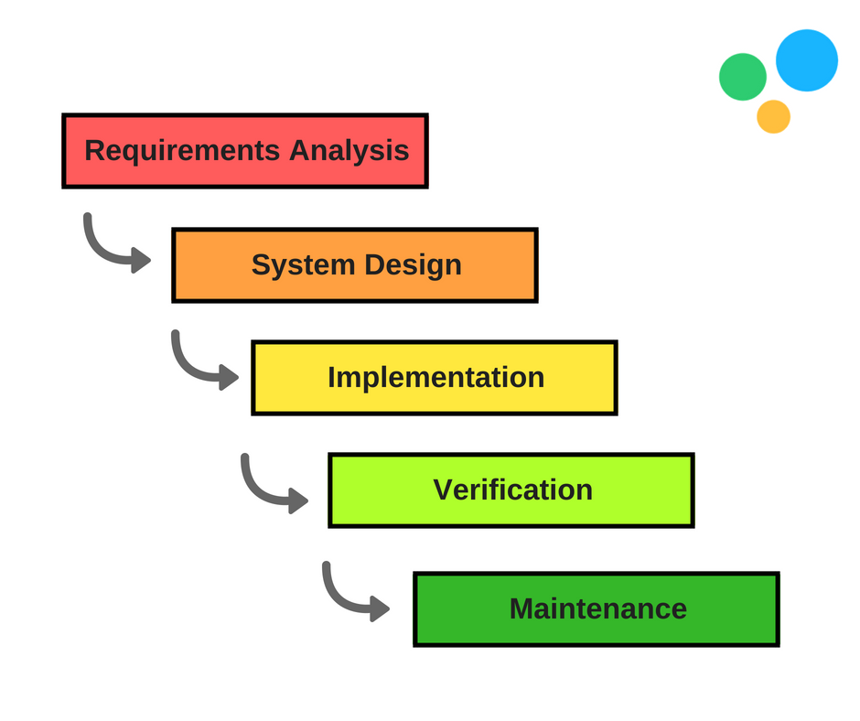

Figure 1: Waterfall Methodology

**7.1 : Requirements Analysis**

The key aspect of waterfall is that all user requirements are gathered at the beginning of the project, allowing every other phase to be planned without further user correspondence until the product is complete. It is assumed that all requirements can be gathered at this phase

**7.2 : System Design**

The design phase of the waterfall process is best broken up into two subphases: logical design and physical design. The logical design subphase is when possible solutions are brainstormed and theorized. The physical design subphase is when those theoretical ideas and schemas are made into concrete specifications.

**7.3 Implementation**

The implementation phase is when programmers assimilate the requirements and specifications from the previous phases and produce actual code.

**7.5 Verification**

This phase is when the customer reviews the product to make sure that it meets the requirements laid out at the beginning of the waterfall project. This is done by releasing the completed product to the customer.

**7.6 Maintenance**

The customer is regularly using the product during the maintenance phase, discovering bugs, inadequate features and other errors that occurred during production. The production team applies these fixes as necessary until the customer is satisfied.

# 8.0 CONCLUSION

As aconclusion this mobile application is one of the steps to help young children to learn about Islam and can help them train to perform worship such as five times prayer, fasting, dhikr and etc. In addition, children can learn Arabic in a nutshell such as recognizing objects, weather, fruits and so on in Arabic. If children are trained to learn Arabic from an early age, they will surely easily understand the meaning of the verses of the Quran. Islamic Education for Children to some extent provide new knowledge for children to develop their brain cells and can be used as they grow into adulthood.

# 9.0 GANTt CHART

|  |  |  |  |  |  |  |  |  |  |  |  |  |
| --- | --- | --- | --- | --- | --- | --- | --- | --- | --- | --- | --- | --- |
| Project Schedule | W1 | W2 | W3 | W4 | W5 | W6 | W7 | W8 | W9 | W10 | W11 | W12 |
| Information Gathering |  |  |  |  |  |  |  |  |  |  |  |  |
| Literature Review |  |  |  |  |  |  |  |  |  |  |  |  |
| Methodology |  |  |  |  |  |  |  |  |  |  |  |  |
| System Requirement |  |  |  |  |  |  |  |  |  |  |  |  |
| Design |  |  |  |  |  |  |  |  |  |  |  |  |
| Implementation |  |  |  |  |  |  |  |  |  |  |  |  |
| Testing |  |  |  |  |  |  |  |  |  |  |  |  |

# 10.0 References

10.1 www.mommyhana.com. (n.d.). *MommyHana Online Store*. [online] Available at: https://www.mommyhana.com/ [Accessed 26 Aug. 2021].

10.2 Chio, R. (2017). *Meluangkan Masa Bersama Anak - 6 Mengapa Ia Sangat Penting*. [online] my.theasianparent.com. Available at: https://my.theasianparent.com/meluangkan-masa-bersama-anak [Accessed 26 Aug. 2021].

10.3 Anon, (n.d.). *Panduan Didik Anak Cara Nabi (Dari Bayi - 10 Tahun)*. [online] Available at: https://www.sishawa.com/2019/07/panduan-didik-anak-cara-nabi.html [Accessed 26 Aug. 2021].

10.4 SEKOLAH PRESTASI GLOBAL. (2021). *11 Aplikasi Terbaik untuk Anak Muslim*. [online] Available at: https://www.prestasiglobal.id/aplikasi-terbaik-untuk-anak-muslim/ [Accessed 26 Aug. 2021].

10,5 BERITA Mediacorp – Berita Terkini, Melayu, Muslim, Islam, Singapura, Dunia. (n.d.). *Mahu anak belajar? Ibu bapa perlu fahami fungsi bermain dari perspektif kanak-kanak - BERITA MediaCorp*. [online] Available at: https://berita.mediacorp.sg/mobilem/gayahidup/mahu-anak-belajar-ibu-bapa-perlu-fahami-fungsi-bermain-dari/4245170.html [Accessed 26 Aug. 2021].

‌10.6 ISMA. (2020). 10 CARA DIDIK ANAK CARA ISLAM. [online] Available at: https://isma.org.my/10-cara-didik-anak-cara-islam/ [Accessed 26 Aug. 2021].

‌